\*.template.htm files watching instruction:

1. Create new custom file watcher (as program use Fake.cmd; Fake.cmd does nothing and always returns 0).

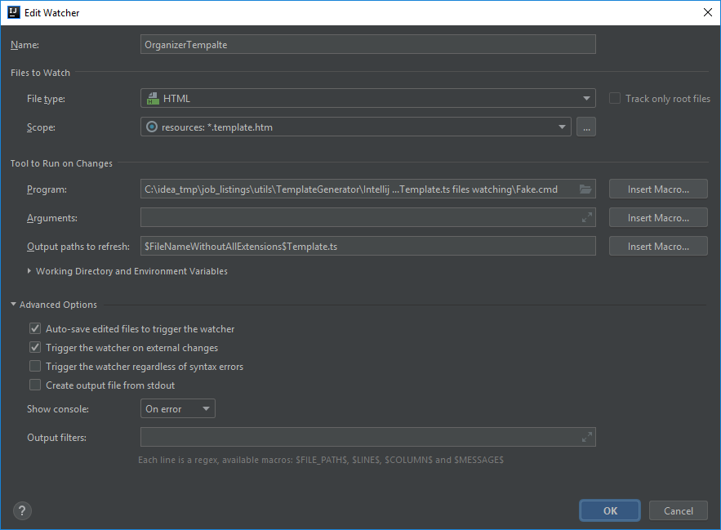

1. Setup scope.

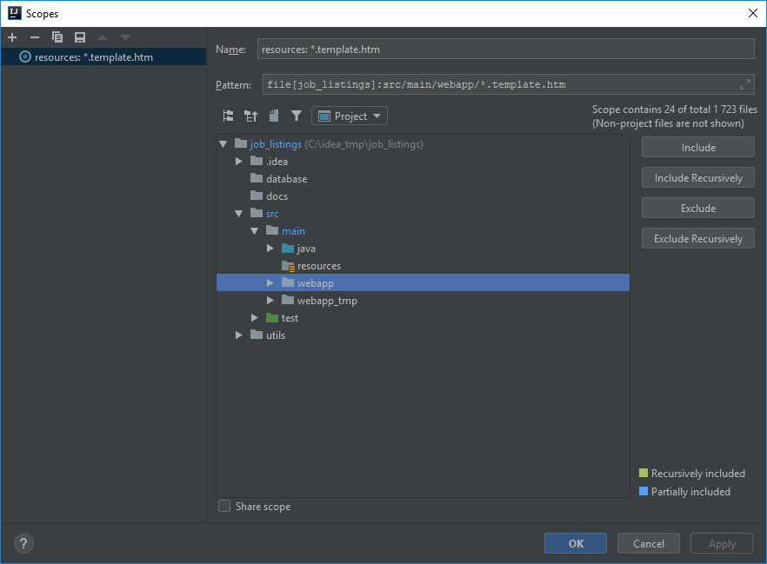

1. Save changes and enable watcher.

